Supplemental Materials

In these folders, from the public github repository, we have several graphs, datasets, and results that are discussed in the text.

In addition, we have several findings that are beyond the scope of the original publication and have been discussed elsewhere. All of the data, results, etc. are to be kept here. Any use or data or citations should point to the appropriate publication or this repository and all data should be used in accordance with the terms of use of the repository as well as the data sources from which they’re drawn (Twitter and Google). By using and downloading the repository you accept that the authors and maintainers of the data are not responsible for any use or damages in relation to yourself or others.

# Regarding trimming of the political spectrum

To ensure that only left wing tweets would be included, we utilized a political classifier to classify each tweet between 0 and 1, removing those deemed on the right wing. Initial analysis revealed a left, right distribution as follows prior to data cleaning:

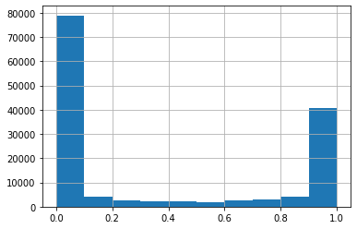

After data cleaning, the distribution was as such:

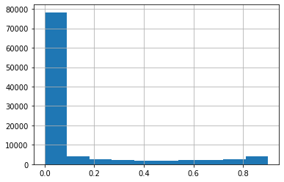

# Additional Geographic Results

Overall, this is the geographic distribution of all tweets.

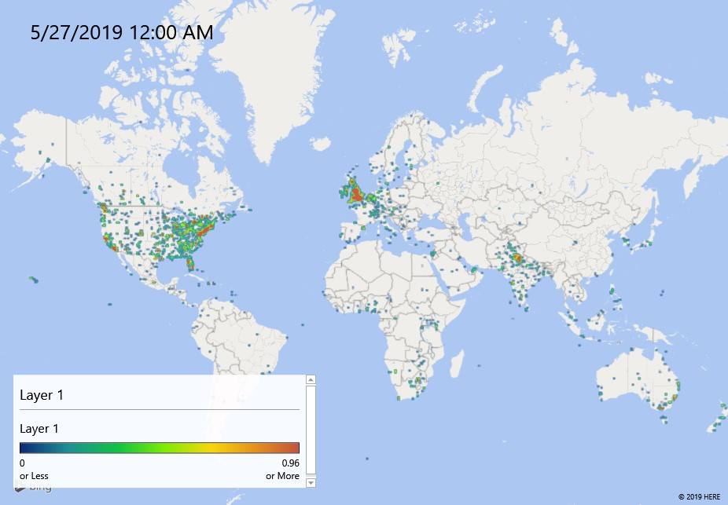

This is the “zoom in” to the US

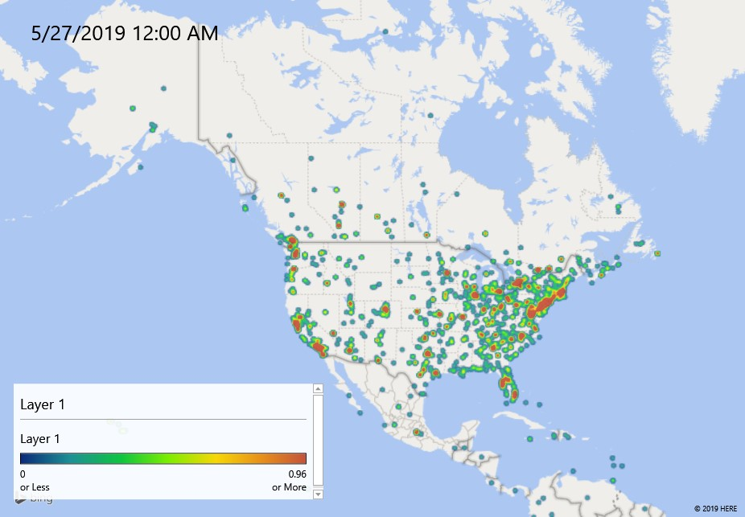

Favorite Count (SUM)

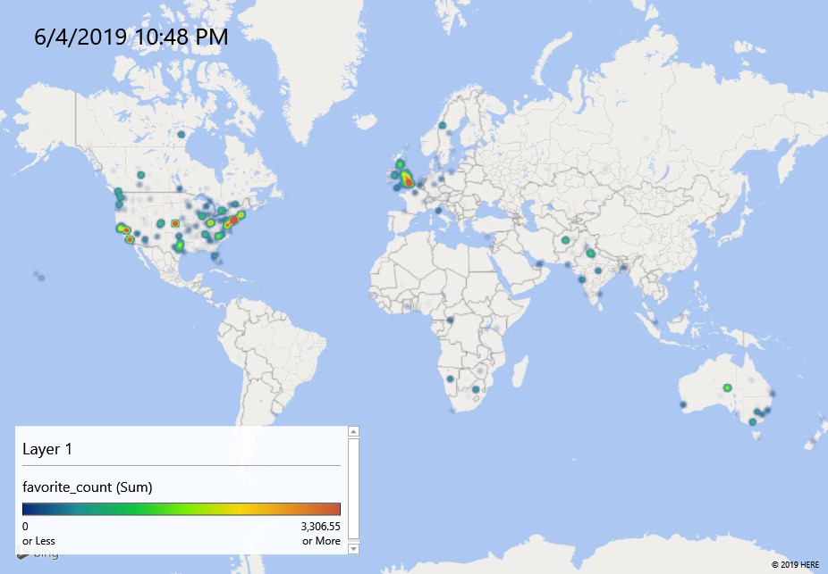

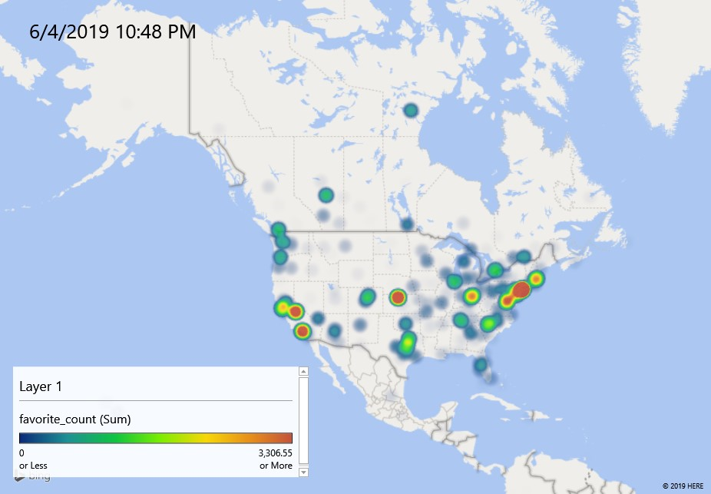

Retweet Count (average)

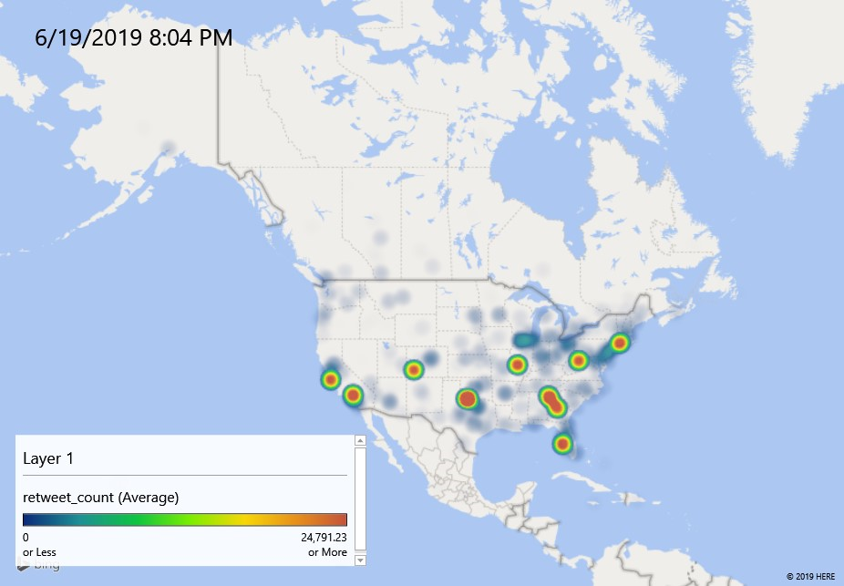

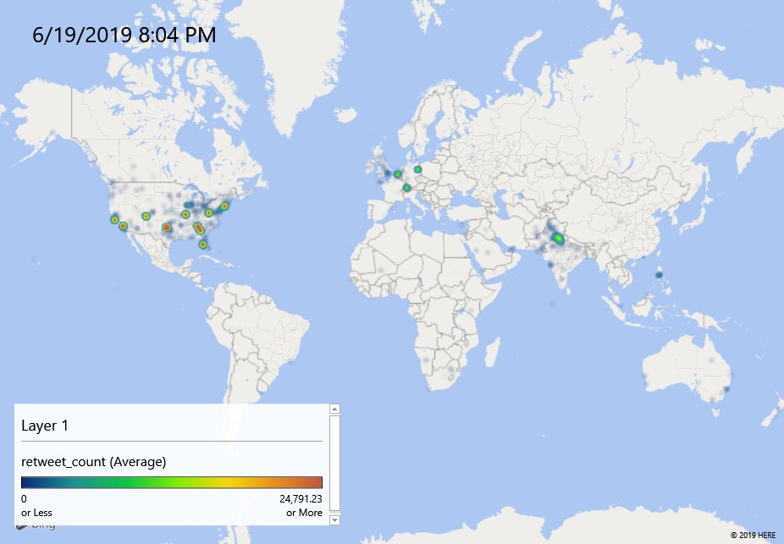

Friends count (SUM)

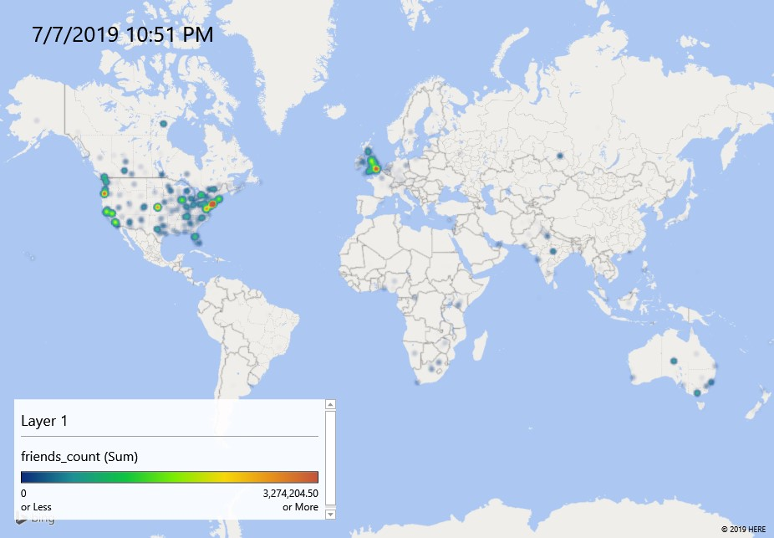

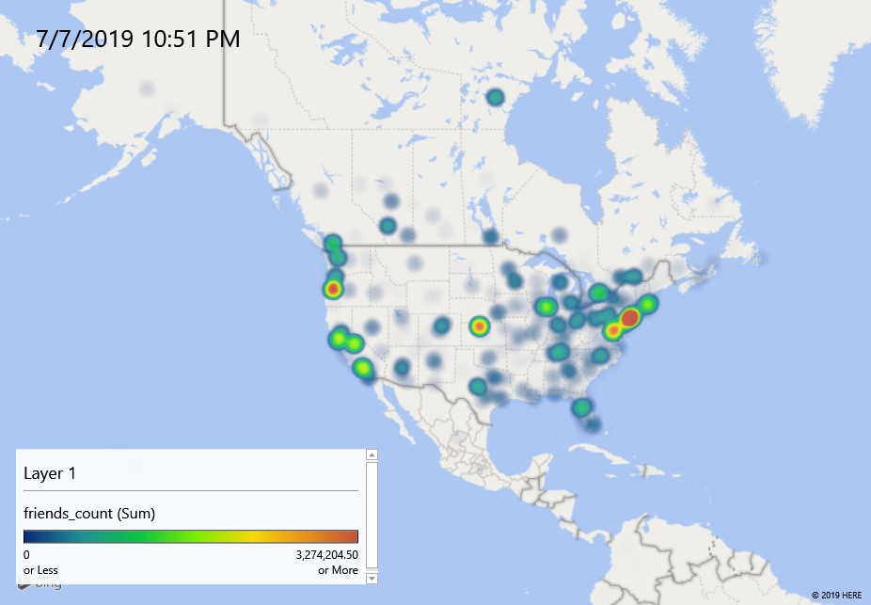

Friends Count (average)

